Index

Contents

**About The City Of Daman** 2

**16 Best Places To Visit In Daman** 3

1. Jampore Beach – Perfect Place To Unwind 3

2. Devka Beach – Ideal Adventurous Location 4

3. Moti Daman Fort – Dig Into The History 5

4. Lighthouse – Soak In The Views 6

5. Church Of Our Lady Of Sea – Pray For Your Loved Ones 6

6. Jain Temple – Pay A Visit 7

7. Hanuman Temple – Ideal Religious Spot 7

8. Mirasol Lake Garden – Engage In Fun-Filled Activities 8

9. Cathedral Of Bom Jesus – Explore The Ruins 9

10. Somnath Mahadev Temple – Meditate & Pray For Well-Being 10

11. Dominican Monastery – Know More About Daman 11

12. Jetty Garden – Relax & Soothe Your Eyes 12

13. Devka Amusement Park – Great Place For Kids 13

14. House Of Bockage – A Historical Place 14

15. Daman Ganga Tourist Complex – Discover Leisure 15

16. Nani Daman Fort – Depicts Christian Culture 16

List of figures

Figure 1: Jampore Beach 4

Figure 2: Devka Beach 5

Figure 3: Moti Daman Fort 5

Figure 4: Light House 6

Figure 5: Church 6

Figure 6: Jain Temple 7

Figure 7: Hanuman Temple 8

Figure 8: Mirasol Lake 9

Figure 9: Cathedral Of Bom Jesus 10

Figure 10: Somnath Mahadev Temple 11

Figure 11: Dominican Monastery 12

Figure 12: Jetty Garden 13

Figure 13: Devka Amusement Park 14

Figure 14: House Of Bockage 15

Figure 15: Daman Ganga Tourist Complex 16

Figure 16: Nani Daman Fort 17

Daman tourist place

*From alluring beaches to historical monuments, and from breathtaking architecture to awe-inspiring landscapes, Daman possesses everything to tickle the travel bug inside you to plan a trip to this paradisiacal piece of land embellishing the western coast of India. With so many options to explore, within this small city, it sometimes becomes difficult to decide that which ones to visit, and which ones to ignore. So, here’s a list of 12****best places to visit in Daman****which you must visit, as they depict the culture, art, and architecture of the city, in the best way possible.*

**About The City Of Daman**

**State:** Union Territory Of Daman & Diu  
**Location:** Situated on the banks of Daman Ganga River  
**Area:** 102 Square Kilometers  
**Best Time To Visit Coimbatore:** October to March  
**Famous For:** Colonial Architecture, and Beaches  
**Distance From Gujrat:** 520 Kilometers (8.5 Hours approx.)  
**Distance From Mumbai:** 177 Kilometers (3 Hours approx.)

# **16 Best Places To Visit In Daman**

Check out these **places to see in Daman** and select the best ones for your vacation this year. You will not be disappointed with the beauty of these places for sure.

* **Jampore Beach** – Perfect Place To Unwind
* **Devka Beach** – Ideal Adventurous Location
* **Moti Daman Fort** – Dig Into The History
* **Lighthouse** – Soak In The Views
* **Church Of Our Lady Of Sea** – Pray For Your Loved Ones
* **Jain Temple** – Pay A Visit
* **Hanuman Temple** – Ideal Religious Spot
* **Mirasol Lake Garden** – Engage In Fun-Filled Activities
* **Cathedral Of Bom Jesus** – Explore The Ruins
* **Somnath Mahadev Temple** – Meditate & Pray For Well-Being
* **Dominican Monastery** – Know More About Daman
* **Jetty Garden** – Relax & Soothe Your Eyes
* **Devka Amusement Park** – Great Place For Kids
* **House Of Bockage** – A Historical Place
* **Daman Ganga Tourist Complex** – Discover Leisure
* **Nani Daman Fort** – Depicts Christian Culture

## 1. Jampore Beach – Perfect Place To Unwind

[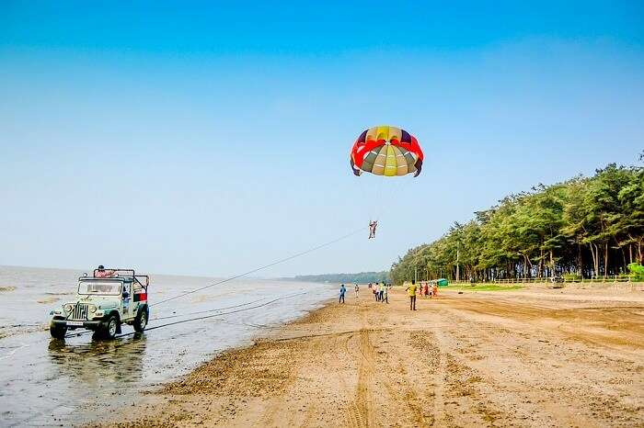](https://assets.traveltriangle.com/blog/wp-content/uploads/2018/01/Adventure-sports-in-Daman.jpg)

Figure 1: jampore beach

[Image Source](https://c1.staticflickr.com/1/674/22218657505_53e8b3dbd6_b.jpg)

Bored of the same old [beaches of Goa](https://traveltriangle.com/blog/famous-beaches-in-goa/)? Then plan a trip to the charming city of Daman which boasts of virgin palm-lined beaches. Jampore Beach is one such pristine beach in the city which is one of the **best places to visit in Daman**, known for numerous [adventure activities](https://traveltriangle.com/blog/adventure-activities-in-karnataka/), enthralling views of the expansive Arabian Sea, and a serene environment to give you a break from the bustling life of the city.

**Location:** Jampore Beach Road, Daman  
**Things To Do At Jampore Beach:** Parasailing. car racing, camel/ horse ride, beach sports, and relaxing in the shacks  
**Time Required:** 1-2 hours  
**How To Reach:** Take a cab from Naini Damin taxi stand  
**What’s Special:** Walk  
**Entry Fee:** Free

**Must Read:**[38 Best Places To Visit In Srinagar That Should Be A Part Of Your Itinerary](https://traveltriangle.com/blog/best-places-to-visit-in-srinagar/)

## 2. Devka Beach – Ideal Adventurous Location

[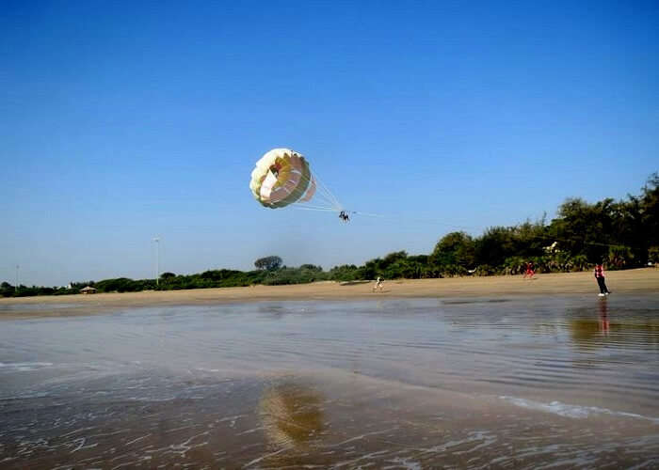](https://assets.traveltriangle.com/blog/wp-content/uploads/2018/01/Beaches-In-daman.jpg)

Figure 2: devka beach

[Image Source](https://gypsycouple.com/wp-content/uploads/2015/09/24.jpg)

Devka Beach is another popular beach in the town which is known for its long shoreline, fun-filled activities, and a tranquil environment. It is one of the most popular **tourist attractions in Daman** which lures numerous tourists every year to soak in the tropical weather while relaxing on the beach beds, and enjoy luscious food from the popular shacks lined across the beach.

**Location:** Devka Beach Road, Daman  
**Things To Do At Devka Beach:** Chug in exotic drinks while relaxing on the beach beds, savor scrumptious food from the nearby joints, indulge in sporting activities, and visit the nearby [amusement park](https://traveltriangle.com/blog/amusement-parks-in-mangalore/)  
**Time Required:** 1-2 hours  
**How To Reach:** Take a cab from naini Damin taxi stand  
**What’s Special:** Adventure sports, horse rides  
**Entry Fee:** Free

## 3. Moti Daman Fort – Dig Into The History

[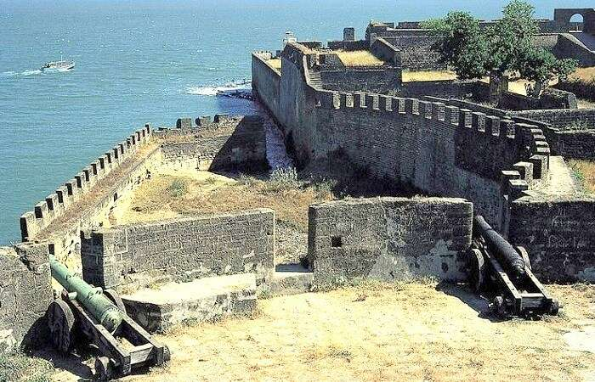](https://assets.traveltriangle.com/blog/wp-content/uploads/2018/01/Moti-Daman-Fort.jpg)

Figure 3: moti daman fort

[Image Source](https://i.pinimg.com/736x/02/db/77/02db77c5d93cd822a1670bfd09704bd1.jpg)

Constructed by the Portuguese, towards the end of sixteenth century, the Moti Daman Fort is one of the most popular monuments in Daman. Even though the fort has worn out, and needs restoration, it is still one of the **best places to visit in Daman** which boasts of Colonial style architecture featuring huge walls, 10 bastions, 2 gateways, and an Iberian church.

**Location:** Moti Daman, Daman and Diu  
**Timings:** 8 am to 4 pm  
**Entry Fee:** INR 10 to INR 15 per person

## 4. Lighthouse – Soak In The Views

[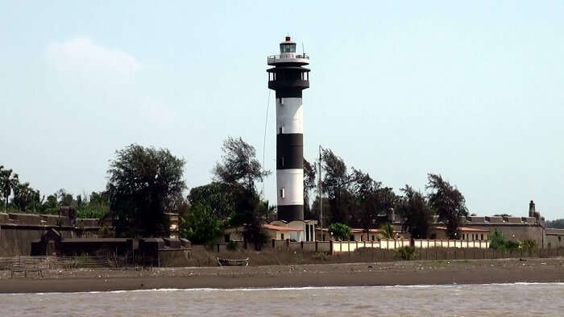](https://assets.traveltriangle.com/blog/wp-content/uploads/2018/01/Lighthouse-Daman.jpg)

Figure 4: light house

[Image Source](https://i.ytimg.com/vi/rBtKZ_uad6Q/maxresdefault.jpg)

Wondering **what to see in Daman**? Then plan a visit to the colossal Lighthouse in Daman. Located in the vicinity of the Moti Daman Fort, Lighthouse is one of the most popular **Daman tourist attractions**. A large number of tourists flock to this place to spectate the marvelous sight of sunset, witness the panoramic views of the Arabian Sea, and the city. It is also a perfect place for photography lovers.

**Location:** Rua Martim Afonso, Fort Area, Moti Daman, Daman, Daman  
**Time Required:** 1-2 hours  
**How To Reach:** Take a cab from Modi Daman  
**What’s Special:** Taking pictures during sunrise, long walls  
**Entry Fee:** Free

**Suggested Read:** [40 Best Places To Visit In India With Friends This December!](https://traveltriangle.com/blog/best-places-to-visit-in-india-with-friends/)

## 5. Church Of Our Lady Of Sea – Pray For Your Loved Ones

[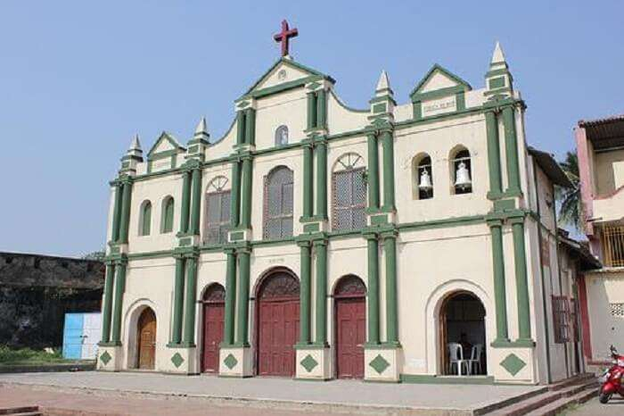](https://assets.traveltriangle.com/blog/wp-content/uploads/2018/01/Church-Of-Lady-of-Sea-Daman.jpg)

Figure 5: church

[Image Source](http://im.hunt.in/cg/Daman/City-Guide/ladych.jpg)

Considered as one of the most sacred worship places in Daman, the Church of Our Lady of Sea, is also one of the **best places to visit in Daman**. Built inside the St Jerome Fort, this holy place is known for its exquisite architecture, and a colossal statue of St Jerome. Other than visiting the church, tourists can also spend some time near the Daman Ganga river to revel in the serenity of nature.

**Location:** Dhamatne, Nani Daman, Daman and Diu  
**Time Required:** 30 mins  
**How To Reach:** Take a cab from city center.  
**What’s Special:** Famous tourist spot, architectural beauty.  
**Entry Fee:** INR 10.00 per person.

## 6. Jain Temple – Pay A Visit

[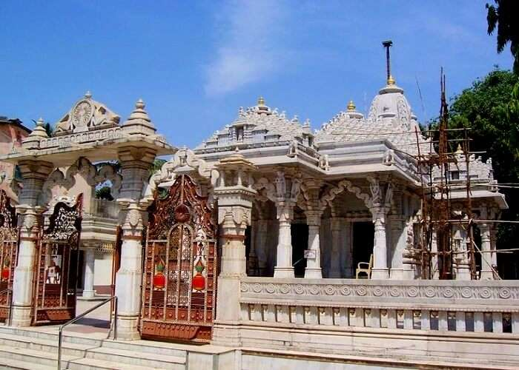](https://assets.traveltriangle.com/blog/wp-content/uploads/2018/01/Jain-Temple-In-Daman.jpg)

Figure 6: jain temple

[Image Source](https://i.pinimg.com/736x/ed/2d/52/ed2d526223a4f6f904e84e9610af079e--daman-and-diu-goa.jpg)

The city of Daman is studded with numerous temples spread throughout the city, with Jain temple being one of the most popular among them. Include a visit to this temple in your**Daman sightseeing** tour to peep into the cultural, and religious beliefs of the sect. This temple is also known for its unique architecture which features 18th-century murals that depict the life of Lord Mahavira, the founder of Jainism.

**Location:** St. Jerome Fort, Nani Daman, Daman  
**Time Required:** 20-30 mins.  
**How To Reach:** Local transport from Ghanchiwad.  
**What’s Special:** Temple vegetarian meals, serenity and peace.  
**Entry Fee:** Free.

## 7. Hanuman Temple – Ideal Religious Spot

[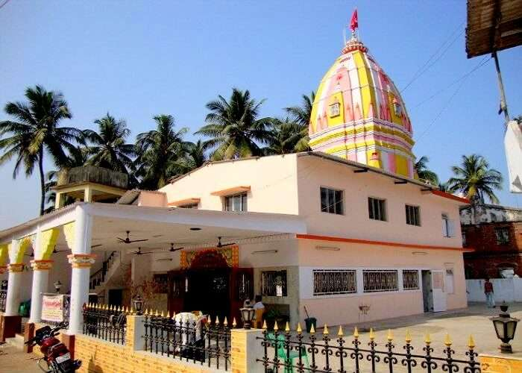](https://assets.traveltriangle.com/blog/wp-content/uploads/2018/01/Hanuman-Temple-Daman.jpg)

Figure 7: hanuman temple

[Image Source](http://photos.wikimapia.org/p/00/01/35/49/01_big.jpg)

As the name suggests, this temple is dedicated to Lord Hanuman. It is one of the **best places to visit in Daman and Diu** if you are looking for religious places during your tour to Daman. Devotees visit this temple to seek knowledge, wealth, relief from diseases, and attain salvation. Located in a peaceful area, this temple also attracts a large number of spiritual seekers who flock here for meditation.

**Location:** Diu, Daman and Diu  
**Time Required:** 20-30 mins.  
**How To Reach:** Local transport from Ghanchiwad.  
**What’s Special:** Medication.  
**Entry Fee:** Free.

**Suggested Read:**[30 Places To Visit In India In April: Beat The Heat This Summer Like A Pro!](https://traveltriangle.com/blog/places-to-visit-in-india-in-april/)

## 8. Mirasol Lake Garden – Engage In Fun-Filled Activities

[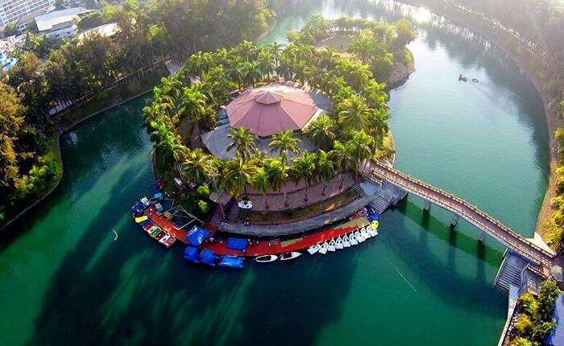](https://assets.traveltriangle.com/blog/wp-content/uploads/2018/01/Mirasol-Lake-Garden.jpg)

Figure 8: mirasol lake

[Image Source](http://www.mirasolresort.com/wp-content/uploads/2017/01/G0017233.jpg)

Looking for peace during your trip to Daman? Then Mirasol Lake Garden is the places to go. Blanketed by a green carpet, and numerous trees, this garden is one of the **best places to visit in Daman** to indulge in an unending affair with nature. The calmness and serenity of the place provide you an opportunity to spend quality time with your loved ones and engage in fun-filled activities for the purpose of entertainment.

**Location:** Near Kadaiya Village, Nani Daman  
**Timings:** 10 am to 6 pm  
**Entry Fee:** INR 10 for adults & INR 5 for children  
**Things To Do:** Boating, and enjoying fun filled rides in the amusement area of the park  
Time Required: 1 hour.  
How To Reach: Bus to Mirosal water park.  
What’s Special: Boat rides,  beautiful lake.  
Entry Fee: INR 30, kids – free.

## 9. Cathedral Of Bom Jesus – Explore The Ruins

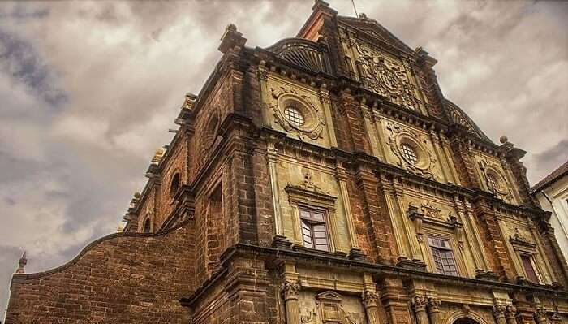

Figure 9: cathedral of bom jesus

[Image Source](https://commons.wikimedia.org/wiki/File:Front_door_of_basilica_bom_jesus.jpg)

Due to a strong connection with Portuguese, Daman is populated with Catholics which makes Cathedral of Bom Jesus one of the top **Daman tourist places**. The construction of this cathedral can be dated back to 1603 and still the building stands strong. The beautiful altarpiece along with the intricately carved doorway has attracted several tourists till now. One must visit this **tourist place in Daman** to witness the craftsmanship and architecture of this place.

**Location:** Manguerial Rd, Fort Area, Moti Daman, Daman, Daman and Diu 396220  
**Timings:** 7 am – 9 pm  
**Time Required:** 1 hour.  
**How To Reach:** 10kms from Panjim tax stand, local cabs available.  
**Entry Fee:** Free.

**Suggested Read:** [5 Best Beach Resorts In Diu For Experiencing Luxury On A Budget](https://traveltriangle.com/blog/best-beach-resorts-in-diu/)

## 10. Somnath Mahadev Temple – Meditate & Pray For Well-Being

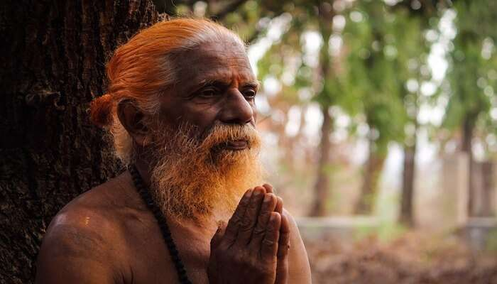

Figure 10: Somnath mahadev temple

Dedicated to Hindu god Lord Shiva, Somnath Mahadev Temple is counted among the top **places to see in Daman**. The Shivlinga in this temple is said to be built in the 19th century after a monk requested it. A fair is hosted every year here which attracts thousands of religious people. It is better to plan your vacation to Daman during this fair as the ambiance is totally different during this time.

**Location:** Somnath – Kachhigam Rd, Somanth, Ringanwada, amiliya, Daman and Diu 396210  
**Time Required:** 1 hour.  
**How To Reach:** 10kms from Panjim tax stand, local cabs available.  
**What’s Special:** Ramon catholic church, Roman style architecture.  
**Entry Fee:** Free.

**Suggested Read:** [7 Quixotic Homestays In Daman That You Can Opt For An Opulent Stay](https://traveltriangle.com/blog/homestays-in-daman/)

## 11. Dominican Monastery – Know More About Daman

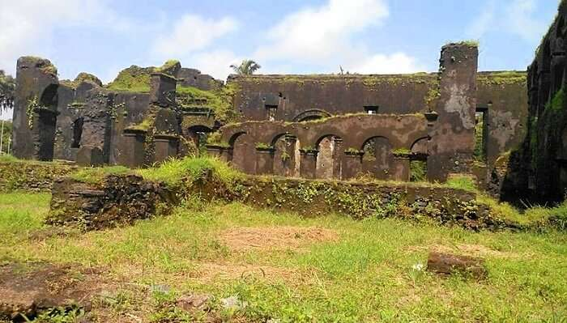

Figure 11: Dominican monastery

[Image Source](https://commons.wikimedia.org/wiki/File:Dominican_Monastery_Daman.jpg)

Dominican Monastery represents the historic ruins which earlier was a catholic monastery. Apart from this, this monastery was also the headquarters of theological studies that attracted many scholars from all around the world. The engravings at the main altar are a sight not to be missed by anyone. So, if you are planning to explore Daman anytime soon then do check out Dominican Monastery.

**Location:** Rua Martim Afonso, Fort Area, Moti Daman, Daman, Daman and Diu 396220  
**Timings:** 12 pm – 12 am  
**Time Required:** 30 mins.  
**How To Reach:** Bus to Rua Martim Afonso, Fort area.  
**What’s Special:** One of the oldest worshiping sites in India.  
**Entry Fee:** Free.

## 12. Jetty Garden – Relax & Soothe Your Eyes

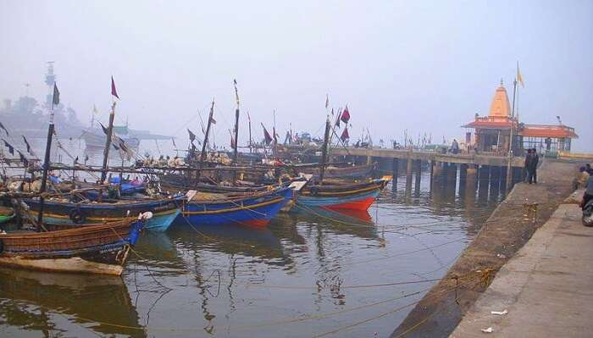

Figure 12: jetty garden

[Image Source](https://commons.wikimedia.org/wiki/File:Daman_Jetty.JPG)

Nestled on the shored of the river Ganga, Jetty Garden has captivated many onlookers with its elegant designs and amazing arrangement of fountains. After exploring all the **Daman tourist places**, you can resort to Jetty Garden and take a stroll or relax amidst the greenery. The view of the river nearby and the green will definitely soothe your eyes. Moreover, a few rides keep kids busy and active.

**Location:** Fort Area, Moti Daman, Daman, Daman and Diu 396220  
**Timings:** Open 24 hours  
**Time Required:** 30 mins.  
**How To Reach:** Take a bus to Fort Area.  
**What’s Special:** Play area, slides.  
**Entry Fee:** INR 10.

## 13. Devka Amusement Park – Great Place For Kids



Figure 13: devka amusement park

One of the best Daman tourist places is the Devka Amusement Park. A simple, old and basic park located by the Devka beach offers various joyrides, boasts a large garden, a food court with special ice cream parlour. It is one of the most amazing [things to do in Daman](https://traveltriangle.com/blog/things-to-do-in-daman/) if you are on a family vacation and especially visiting with kids. Get the amazing opportunity to remember your childhood as you can also enjoy camel and pony rides as well.

**Location**: Devka Beach Rd, Opp.Hotel Ashoka Palace, Nani Daman, Daman, Daman and Diu 396210  
**Timing:**9 am – 9 pm  
**Time Required:** 1 hour.  
**How To Reach:** Alongside Devka Beach road, cab, or local transport available.  
**What’s Special:** Small rides, beaches.  
**Entry Fee:** INR 5.

## 14. House Of Bockage – A Historical Place

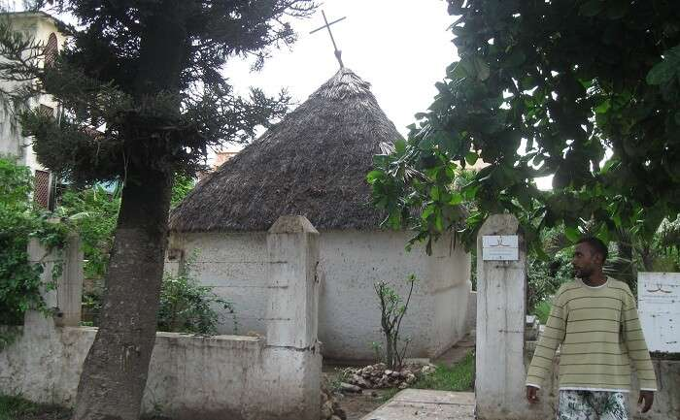

Figure 14: house of bockage

One of the most historical yet not the most favorable **places to see in Daman** is the House of Bockage. Located inside the Moti Daman fort and apparently being used as a warehouse by the locals, only the tourists visit this place for a short time. It is named after a Portuguese poet and a deserter and will surely remind you of the colonial times.

**Location**: Moti Daman, Daman, Daman and Diu 396220  
**Timing:**Open all times  
**Time Required:** 30 mins.  
**How To Reach:** Take a bus to Moti Daman.  
**What’s Special:** Historical place with facts.  
**Entry Fee:** 5 INR.

## 15. Daman Ganga Tourist Complex – Discover Leisure

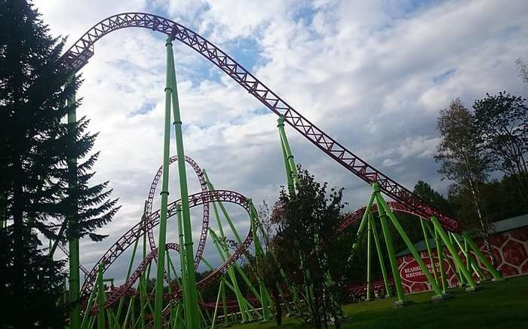

Figure 15: daman ganga tourist complex

One of the greatest tourist places in Daman is a complex built solely for the purpose of leisure in the form of a complex. To feel a classical charm, engage in boating, strolling by the lake and [shopping in Daman](https://traveltriangle.com/blog/shopping-in-daman/), there can be no better place the the Daman Ganga Tourist Complex. A garden area inside the complex boasts of light fountains that glow in the evening while you enjoy a great picnic with your family. Some other attractions include artificial waterfalls, islands, cafeteria, conference halls and amphitheatre. Now, isn’t that  a dose of entertainment!

**Timing:**7 am – 6 pm   
**Entrance Fee**: INR 10  
**Time Required:** 30 mins.  
**How To Reach:** Take a bus to Valley Resort, Daman.  
**What’s Special:** Jain temples, Statue of Unity.  
**Entry Fee:** INR 50.

## 16. Nani Daman Fort – Depicts Christian Culture

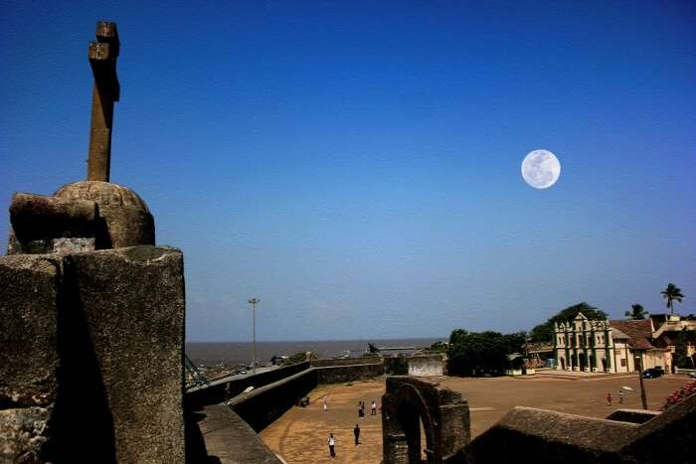

Figure 16: nani daman fort

Nani Daman Fort is one of the most amazing tourist places in Daman.  Also popular as the St. Jerome fort, it is a small fort with massive walls made up of stone. Situated on the bank of river Daman Ganga, the fort has an area of 12,250 sq. meters. The fort depicts the Christian culture in many ways with a church, Our Lady of the Sea, in the vicinity and a huge statue of St. Jerome at the fort’s entrance. Some other attractions near the fort include the Gandhi Park and a fish market with several fishing boats at the shore.

**Location**: Near, Nani Daman, jetty, Daman and Diu 396210  
**Timing:**8 am – 6 pm  
**Time Required:** 20-30 mins.  
**How To Reach:** Can be reached using a boat to Jetty Point, Daman.  
**What’s Special:** Jain temples, Statue of Unity.   
**Entry Fee:** INR 10

**Further Read:**[10 Marvelous Places To Visit Near Diu For A Great Weekend Getaway](https://traveltriangle.com/blog/places-to-visit-near-diu/)

***So, these are the best places to visit in Daman that no one can afford to miss if they are traveling to this destination. Like these there many such famous places to visit in Daman that can light up your mood. The place is not too big but it never falls short of the things to do. These tourist places in Daman will surely not disappoint you and you will catch some amazing glimpses of the surroundings. What are you waiting for now? Plan your***[***trip to Daman & Diu***](https://traveltriangle.com/tour-packages/diu?utm_source=Blog_bs%22%20target=%22_blank)***now and surprise your family or friends with an excursion.***

***Disclaimer:****TravelTriangle claims no credit for images featured on our blog site unless otherwise noted. All visual content is copyrighted to its respectful owners. We try to link back to original sources whenever possible. If you own the rights to any of the images, and do not wish them to appear on TravelTriangle, please contact us and they will be promptly removed. We believe in providing proper attribution to the original author, artist or photographer.*

***Please Note:****Any information published by TravelTriangle in any form of content is not intended to be a substitute for any kind of medical advice, and one must not take any action before consulting a professional medical expert of their own choice.*